**Human Computer Interaction**

**12th assignment**

1. Describe two situations in which a joystick might be preferred over a mouse.
2. Describe three techniques that you would use to elicit user requirements for a new e-commerce site selling electrical appliances, such as fridges and televisions, to the public.
3. Why and when Low and high fidelity prototypes are used in the software development project?
4. Figure 1 is the design for a snack vending machine that dispenses several different types of snacks. The users can see a selection of snacks through the transparent window in which several types of snacks are displayed along with the price. The steps to perform this operation are written on the vending machine.

• There are two indicators; one is to inform the users if the machine is out of order and the

* There are two indicators one to inform the user if the machine is out of order and the other one is for exact change only.
* The users need to select a snack first by pressing on the keypad to enyter the code displayed under each snacks and then feed coins into the slot.

* When the user insert coins, there is a panel to display the amount of coins inserted.
* When the amount is sufficient, he selected snack will be displayed and any unspent money will be returned.
* If at any time the users want to cancel the purchase, the can press a button and the money will be returned.

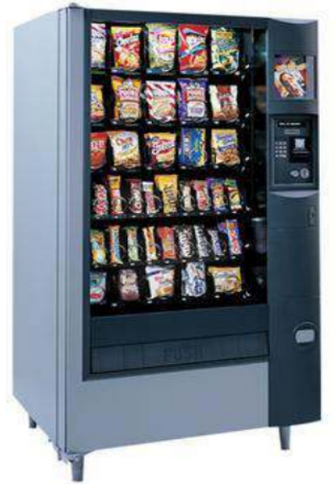

• There are two indicators; one is to inform the users if the machine is out of order and the

There are two indicators; one is to inform the users if the machine is out of order and the

• There are two indicators; one is to inform the users if the machine is out of order and the

**Figure 1: Snack vending machine**

Using the hierarchical task analysis (HTA), construct the task diagram and plan(s) for the process of buying a chocolate from the vending machine.

(Hints: Provide your answer in textual representation and graphical view)